**Department of Electrical Engineering**

|  |  |
| --- | --- |
| **Faculty Member: Ma’am Qurat-ul-ain** | **Dated: November 19, 2020** |
|  |  |
| **Course/Section: BSCS-9B** | **Semester: 3rd** |
|  |  |

**Computer Organization and**

**Assembly Language (CS235)**

**Lab #6 Arduino Uno for blinking Led using Digital pins on Tinkercad**

|  |  |  |  |  |  |  |  |
| --- | --- | --- | --- | --- | --- | --- | --- |
|  | | **PLO4 / CLO4** | | **PLO5/ CLO5** | **PLO8/ CLO 6** | **PLO9/ CLO 7** |  |
| **Name** | **Roll number** | **Viva /Quiz/ Lab performance**  **5 marks** | **Analysis of data in lab report**  **5 marks** | **Modern tool Usage**  **5 marks** | **Ethics and Safety**  **5 marks** | **Individual and team work**  **5 marks** | **Total**  **25 marks** |
| **Fatima Seemab** | **291310** |  |  |  |  |  |  |
| **Mahum Samar** | **290647** |  |  |  |  |  |  |
| **Maryam Fatima** | **290479** |  |  |  |  |  |  |

**Objective:** The aim of this lab is to get familiarize with Arduino uno and to use Arduino Uno for blinking Led using Digital pins on Tinkercad

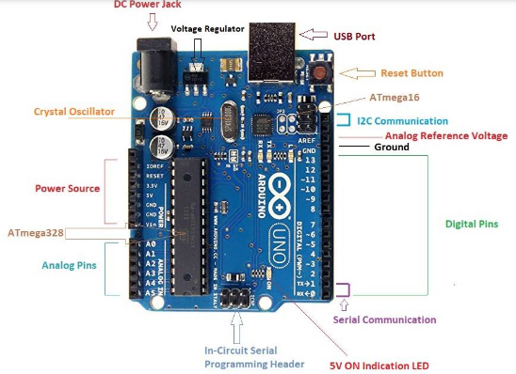



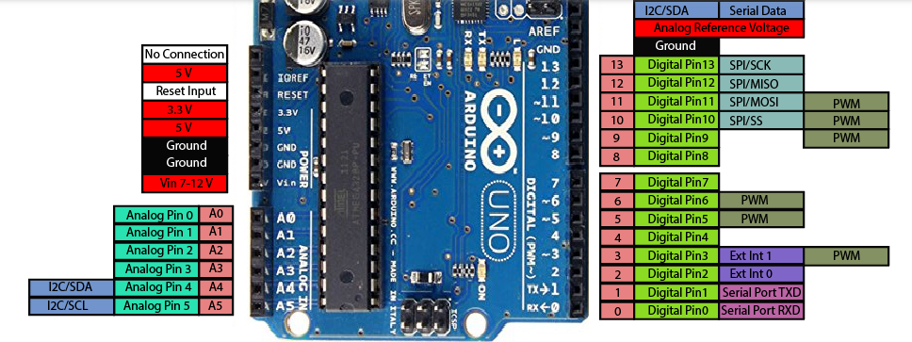



Arduino Uno is based on AVR microcontroller called Atmega328. This controller comes with 2KB SRAM, 32KB of flash memory, 1KB of EEPROM. Arduino Board comes with 14 digital pins and 6 analog pins. ON-chip ADC is used to sample these pins. A 16 MHz frequency crystal oscillator is equipped on the board.



In tinkercad, You can code using either blocks or Text. (Use of text code is preferable)

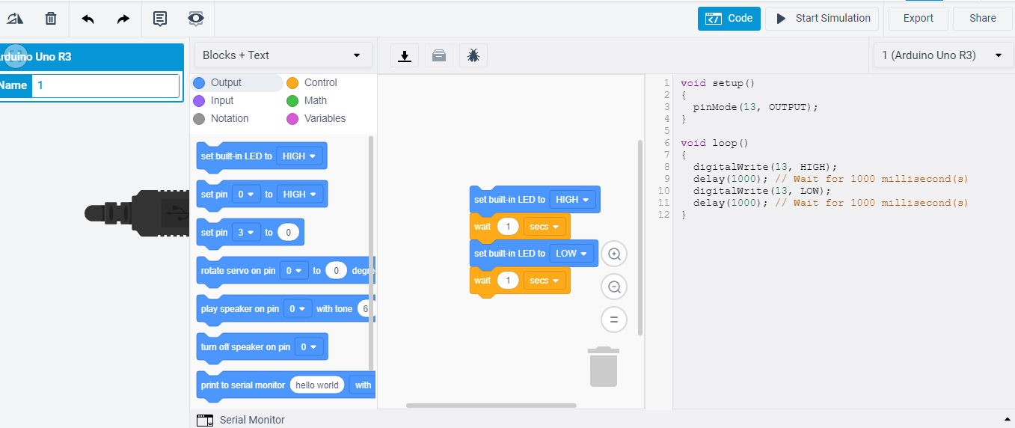



**Text Code: (Case sensitive)**



The **setup()** function is use it to initialize the variables, pin modes, start using libraries, etc.



the **loop()** function does precisely what its name suggests, and loops consecutively, allowing your program to respond.

Void setup () {

pinMode(3,INPUT) ;

}

Or

int button = 5 ; // button connected to pin 5

int LED = 6; // LED connected to pin 6



void setup () {



pinMode(button , INPUT); // set the digital pin as input

pinMode(button , OUTPUT); // set the digital pin as output

}

digitalWrite (pin ,value); // Value can be high or low; Pin show pin number or variable referring to pin number

**Code blocks**

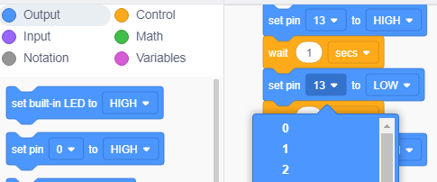

**Getting started with Arduino Uno on Tinker cad:**

Step 1:

Go to <https://www.tinkercad.com/>

Click join now/sign in

**I**f tinkercad not opening and giving an error like *IP address not found*, follow the steps given in video

<https://www.youtube.com/watch?v=wx0cPuTUYrM>

After sign in, Click Circuit🡪 then create new circuit

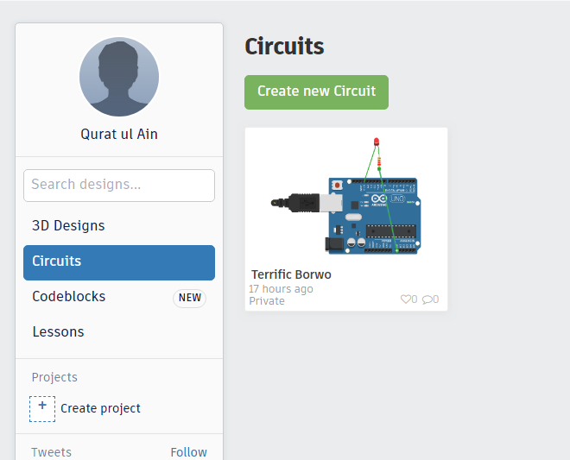

Screen similar to this will appear

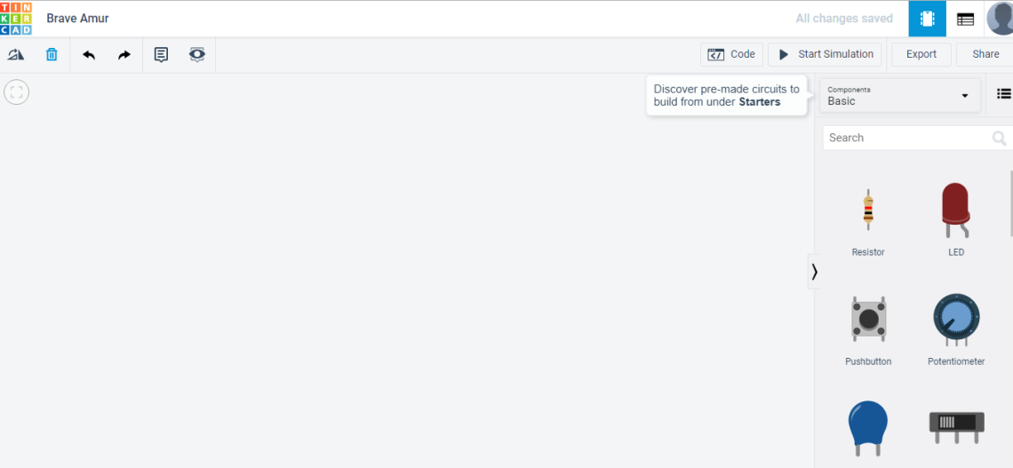

In search enter arduino and select arduino

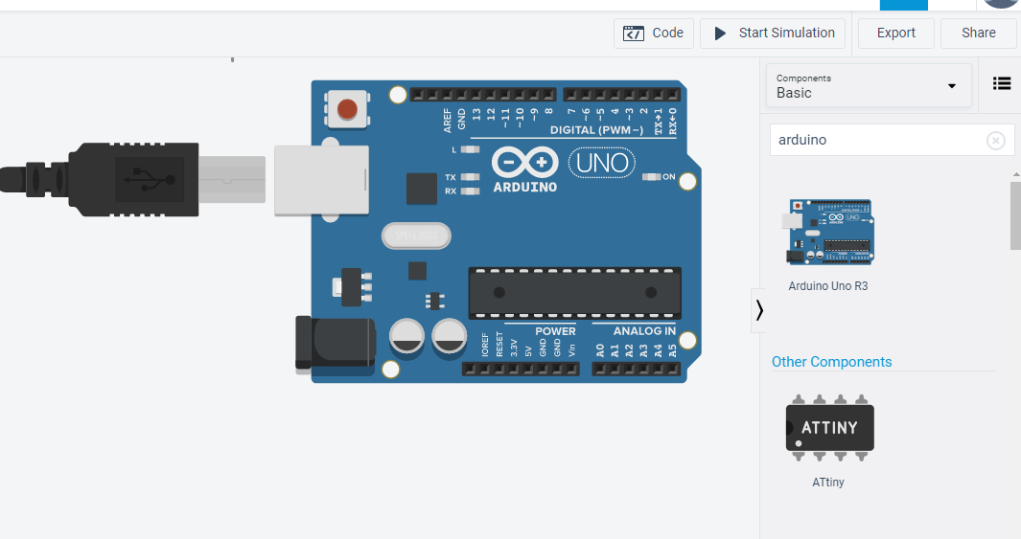

You can select led and resistor according to your requirement.

You can click start simulation in order to see circuit working. You can also view the code from code section.

**Tinkercad Task:**



1. Blink Led on pin 4 with delay of 1 sec. Use 220 ohm resistor between led -ve pin and ground.

**Code:**

void setup()

{

pinMode(4, OUTPUT);

}

void loop()

{

digitalWrite(4, HIGH);

delay(1000); // Wait for 1000 millisecond(s)

digitalWrite(4, LOW);

delay(1000); // Wait for 1000 millisecond(s)

}

[](Task01.gif)

1. Blink two leds, one on pin 6 and other on pin5, such that each led blink one after the other.

(Hint: You must adjust the delay in such a way that led blink one after the other)

**Code:**

void setup()

{

pinMode(5, OUTPUT);

pinMode(6, OUTPUT);

}

void loop()

{

digitalWrite(5, HIGH);

digitalWrite(6, LOW);

delay(1000); // Wait for 1000 millisecond(s)

digitalWrite(5, LOW);

digitalWrite(6, HIGH);

delay(1000); // Wait for 1000 millisecond(s)

}

**[](Task02.gif)**



**Note**:

The attached illustrations are GIFs and can be viewed by pressing CTRL + CLICK on illustration.